

Document Version History

***Prepared by Webdunia***

***Version 1.0***

***Brothers Ecommerce***

***Framework Execution Run-book***

Webdunia (India) Pvt. Ltd.

Labh Ganga 582, M G Road

Indore 452 003

Madhya Pradesh, INDIA

Tel: +91-731-4273409  
Web: [www.webdunia.net](http://www.webdunia.net)

www.webdunia.com

|  |  |  |  |  |  |  |
| --- | --- | --- | --- | --- | --- | --- |
| **Version** | **Date** | **Addition/Modification** | **Prepared By** | | **Reviewed By** | **Approved By** |
| 1.0 | June 6, 2020 | Updated | | Arth Kumar | Gaurav V | Babita Jain |

Contents

1. Brothers Framework Execution Run-book 3

1.1 Execution Environment 3

1.1.1 QA (Test Server) 3

1.1.2 PROD (Production Server) 3

1.1.3 DEV (Development Server) 3

1.2 Execution Browser 3

1.2.1 chrome-ng 4

1.2.2 chrome-headless 4

1.2.3 chrome-grid 4

1.3 Execution Modes 4

1.4 Parallel Execution 5

1.5 Sequential Execution: 6

# Brothers Framework Execution Run-book

Brothers Framework has different capabilities like Browser-based, API based applications. In this document, we’ll see how to execute these different capabilities.

## Execution Environment

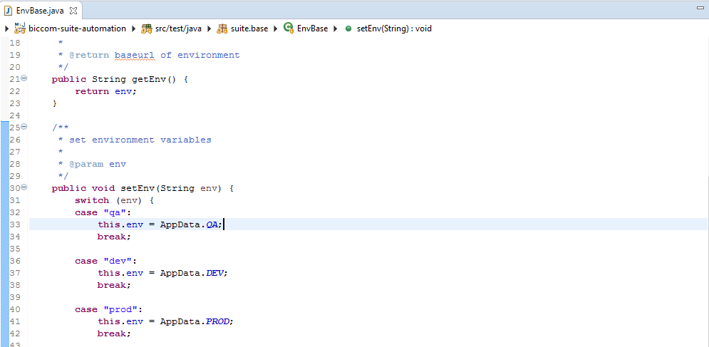

In browser-based execution, we used different environment variables to run and the browser instances. There are following 3 environments variables for running the test cases:

### QA (Test Server)

### PROD (Production Server)

### DEV (Development Server)

Example: AppData file required changes(env.)

## Execution Browser

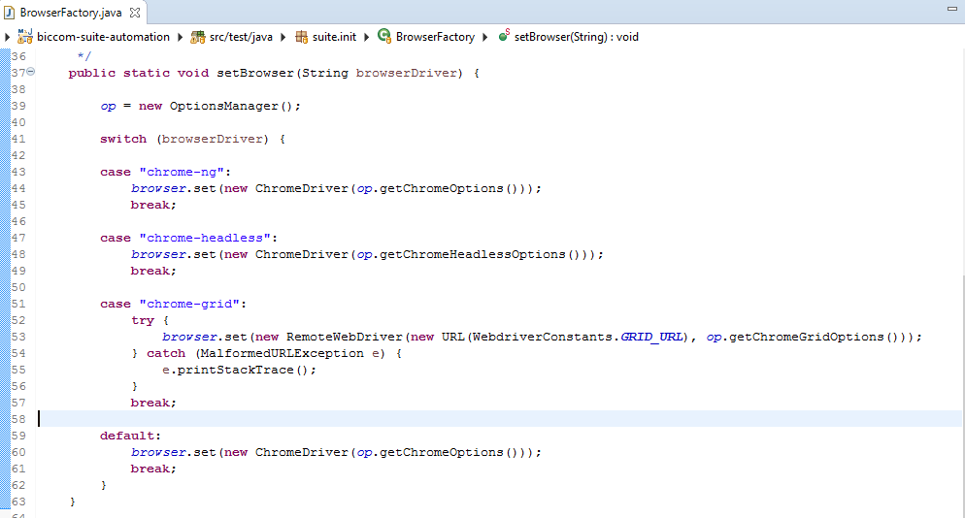

Also, there are different chrome execution options available to run chrome browser in different environment, such as

### chrome-ng

### chrome-headless

### chrome-grid

## Execution Modes

Let’s first understand testng.xml file.

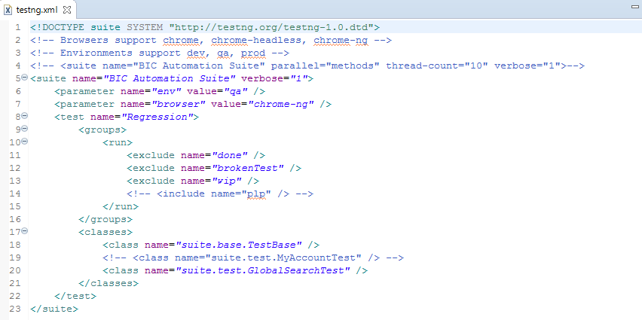

* TestNG is a testing framework for Java that helps to organize test cases in a structured way, and enhances maintainability and readability to the code.
* TestNG contains an XML file where we can set attributes owing to the test cases.
* For example: TestNG allows us to set different parameters such as :
* Test execution modes: QA/PROD/DEV
* Execution Browser: chrome-ng/chrome-headless/chrome-grid.
* Groups to exclude the running of some test cases.
* Class/Classes name to run their test cases.
* Other than the above declared features, TestNG also provides us the following features for the execution of test cases:
* Sequential execution, and
* Parallel execution

## Parallel Execution

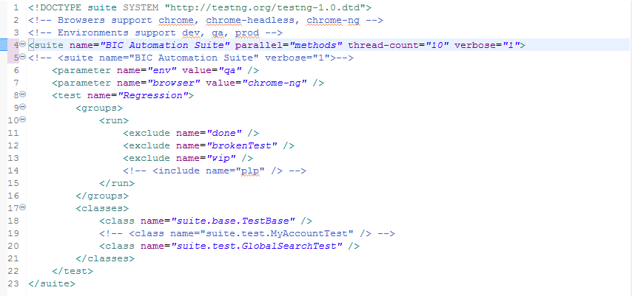

* Parallel testing helps to reduce execution time and efforts and results in faster time to delivery.
* TestNG provides an XML file, where we can set the parallel attribute to method/tests/classes.
* Also, by using the concept of multi-threading of Java, we can set the number of threads, we want to create for parallel execution.
* Below is the structure for defining this attribute in the TestNG XML:

<suite name="BIC Automation Suite" parallel="methods" thread-count="10" verbose="1">

Where,

* **thread-count**: This is used for parallel execution, based on the number script. It will execute in parallel or sequential order.
* **verbose**:  It is used to log the execution details in the console. The value should be 1-10. The log details in the console window will get more detailed and clearer as you increase the value of the verbose attribute in the testng.xml configuration file.
* **suite name**: name of the suite.
* **Parallel**: To run scripts parallel, value can be tests/classes/methods/suites.
* The parallel values can be extended for multiple values, be it:
* **methods**: Helps run methods in separate threads.
* **test:** Helps to run all methods belonging to the same tag in the same thread.
* **classes:** helps to run all methods belonging to a class in a single thread.

## Sequential Execution:

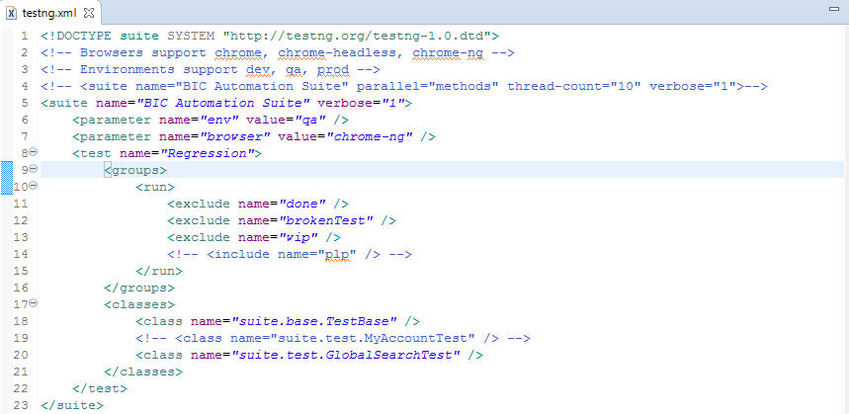

* Sequential execution is to run the test cases sequentially, i.e., the order in which they are written.
* Below is the structure:

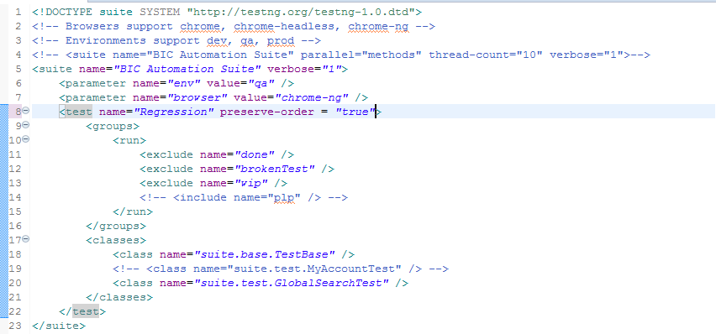



<test name="Regression" preserve-order = "true">